SME to explain the following aspects:

- What happens in the controller method?
@RequestMapping("/country")
- This spring annotation helps to map “/country” to this method
- When the user send GET request to http://localhost:8083/country then this method is executed
ApplicationContext context = new classPathXmlApplicationContext("country.xml");
- It is Interface is Spring used to manage beans
- classPathXmlApplicationContext – it loads the spring configuration from XML file “country.xml”
context.getBean(“country”)
- it retrives the bean with ID “country”
- this bean contains predefine code and name
return country
- Then the country object is returned as HTTP response
- @Restcontroller – automatically convert it into JSON

- How the bean is converted into JSON reponse?
The spring boot detects the return type is not string or view , but it is POJO (Plain old java object);
@Restcontroller , then the spring treats the return value as the response body
Country{ code="IN", name="India" } into {
"code": "IN",
"name": "India"

}

- In network tab of developer tools show the HTTP header details received
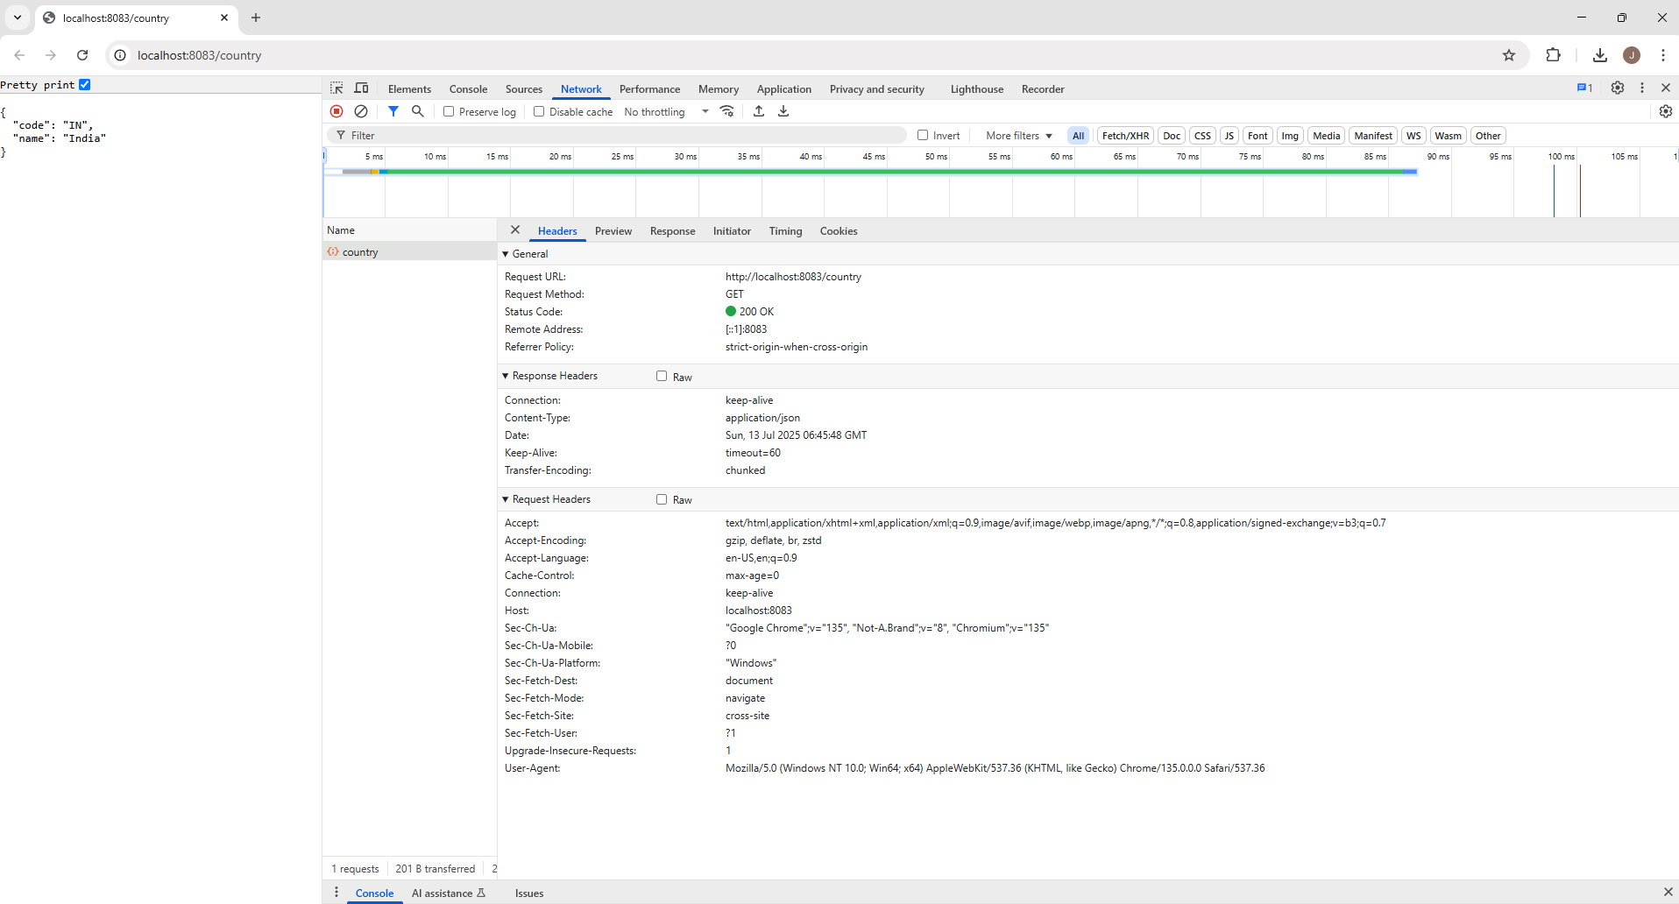
- In postman click on "Headers" tab to view the HTTP header details received

